**Experinment no:9**

**Aim: Miniproject**

**Input:**

**Activity_main.xml**

<?xml version="1.0" encoding="utf-8"?>  
<LinearLayout  
 xmlns:android="http://schemas.android.com/apk/res/android"  
 xmlns:app="http://schemas.android.com/apk/res-auto"  
 xmlns:tools="http://schemas.android.com/tools"  
 android:background="@color/colorPrimaryDark"  
 android:layout_height="match_parent"  
 android:layout_width="match_parent"  
 android:orientation="vertical"  
 tools:context="com.example.myapplication54.CalendarActivity">  
  
 <TextView  
 android:id="@+id/myDate"  
 android:layout_height="wrap_content"  
 android:layout_marginLeft="85dp"  
 android:layout_marginTop="48dp"  
 android:layout_width="wrap_content"  
 android:text="Mark Your Dates"  
 android:textAlignment="center"  
 android:textColor="#FFF"  
 android:textSize="23dp" />  
  
 <LinearLayout  
 android:layout_marginLeft="44dp"  
 android:background="@drawable/bg_calen"  
 android:layout_height="wrap_content"  
 android:layout_marginTop="48dp"  
 android:layout_width="300dp">  
  
 <CalendarView  
 android:id="@+id/calendarView"  
 android:layout_height="320dp"  
 android:layout_width="wrap_content">  
  
 </CalendarView>  
 </LinearLayout>  
  
 <Button  
 android:id="@+id/btn1"  
 android:layout_width="wrap_content"  
 android:layout_height="wrap_content"  
 android:layout_marginLeft="105dp"  
 android:layout_marginTop="34dp"  
 android:background="@drawable/bg_btn"  
 android:onClick="onSelectedDayChange"  
 android:paddingLeft="20dp"  
 android:paddingRight="20dp"  
 android:text="Save My Date"  
 android:textColor="#FFF" />  
  
</LinearLayout>

**Bg_btn.xml**

<?xml version="1.0" encoding="utf-8"?>  
<shape xmlns:android="http://schemas.android.com/apk/res/android">  
  
 <corners  
 android:radius="10dp"  
 />  
 <solid  
 android:color="@color/colorAccent"  
 />  
</shape>

**Bg_calen.xml**

<?xml version="1.0" encoding="utf-8"?>  
<shape xmlns:android="http://schemas.android.com/apk/res/android">  
  
 <corners  
 android:radius="10dp"  
 />  
 <solid  
 android:color="#FFF"  
 />  
</shape>

Android mainefest.xml

<?xml version="1.0" encoding="utf-8"?>  
<manifest xmlns:android="http://schemas.android.com/apk/res/android"  
 package="com.example.myapplication54">  
  
 <application  
 android:allowBackup="true"  
 android:icon="@mipmap/ic_launcher"  
 android:label="@string/app_name"  
 android:roundIcon="@mipmap/ic_launcher_round"  
 android:supportsRtl="true"  
 android:theme="@style/AppTheme">  
 <activity android:name=".CalendarActivity">  
 <intent-filter>  
 <action android:name="android.intent.action.MAIN" />  
  
 <category android:name="android.intent.category.LAUNCHER" />  
 </intent-filter>  
 </activity>  
 </application>  
  
</manifest>

**Calender activity.java**

package com.example.myapplication54;  
  
import androidx.annotation.NonNull;  
import androidx.appcompat.app.AppCompatActivity;  
  
import android.content.Intent;  
import android.os.Bundle;  
import android.view.View;  
import android.widget.Button;  
import android.widget.CalendarView;  
import android.widget.TextView;  
  
public class CalendarActivity<calendarView> extends AppCompatActivity {  
 Button btn1;  
 CalendarView calendarView;  
 TextView myDate;  
  
 @Override  
 public void onCreate(Bundle savedInstanceState) {  
 super.onCreate(savedInstanceState);  
 setContentView(R.layout.activity_main);  
 btn1=(Button)findViewById(R.id.btn1);  
  
 calendarView=(CalendarView) findViewById(R.id.calendarView);  
 myDate =(TextView) findViewById(R.id.myDate);  
  
 calendarView.setOnDateChangeListener(new CalendarView.OnDateChangeListener() {  
 @Override  
 public void onSelectedDayChange(@NonNull CalendarView calendarView, int i, int i1, int i2) {  
 String date=(i1+1)+ "/"+i2+"/"+i;  
 myDate.setText(date);  
  
  
  
 }  
  
  
  
  
 });  
  
  
 }  
}

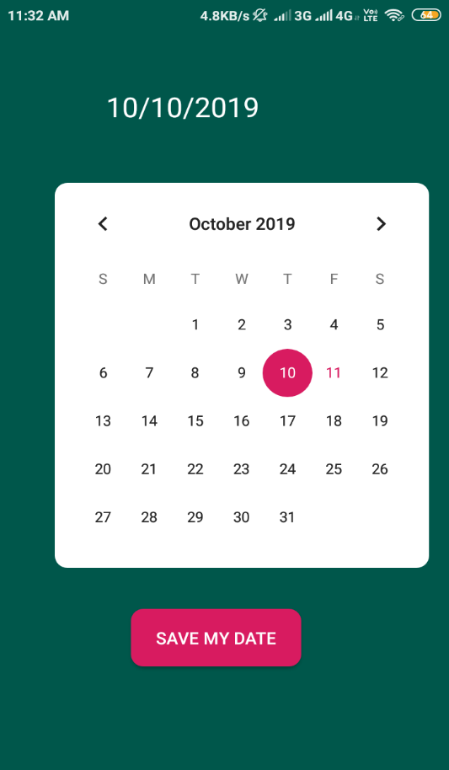**output:**

